Embedded system assignment(3,4,5)

1. **List the differences between 1) Digital and analog data 2) Serial and parallel data transfer**

| Digital data | Analog data |
| --- | --- |
| Continuous signals | Discrete signals |
| Represented by sine waves | Represented by square waves |
| Human voice, natural sound, analog electronic devices are a few examples | Computers, optical drives, and other electronic devices |
| Continuous range of values | Discontinuous values |
| Records sound waves as they are | Converts into a binary waveform |
| Only used in analog devices | Suited for digital electronics like computers, mobiles and more |

| Series data transfer | Parallel data transfer |
| --- | --- |
| Serial data transfer involves sending data one bit at a time, sequentially, over a single data channel or wire. | Parallel data transfer involves sending multiple bits of data simultaneously over multiple data channels or wires. |
| It uses a single communication path, which can be a single wire or a pair of wires (for bidirectional communication). | Each bit of data has its dedicated channel, so all bits can be transmitted at the same time. |
| Serial data transmission is slower compared to parallel transmission because each bit is sent one after the other. | Parallel data transmission is faster than serial transmission because it can send multiple bits in parallel, reducing the overall transmission time. |
| It is often used for long-distance communication, as it is less susceptible to signal degradation over extended cable lengths. | It is commonly used for short-distance communication within computer systems, where speed is essential. |
| Serial communication is commonly found in technologies like RS-232, USB, Ethernet (for some parts of communication), and serial ports on microcontrollers. | Examples of parallel communication include the memory buses within a computer, such as the address bus and data bus, where multiple bits are transferred in parallel. |

1. **Explain following 3 basic steps in analog to digital conversion i) Sampling ii)Holding iii)Quantisation**

Sol: Sampling: is a process of measuring the amplitude of a continuous-time signal at discrete instants, converting the continuous signal into a discrete signal.

Holding: After the analog signal is sampled, the sample and hold circuit holds or "freezes" the value of the sampled signal for a brief period until it can be accurately quantized (converted into a digital value). During this holding phase, the voltage or value of the signal is maintained constant.

* The reason for holding is to ensure that the analog signal's value does not change while it is being quantized. Without holding, if the signal were to change between the time it's sampled and the time it's quantized, the digital representation would not accurately reflect the original signal.

Quantization: After the holding phase, the held analog value is converted into a digital representation through quantization. Quantization involves mapping the continuous range of the analog signal to a finite set of discrete digital values. Each digital value corresponds to a specific range or level of the analog signal.

1. **Explain the following communication Protocols, with its frame formats,**

**a. UART**

**b. I2C**

**C. SPI**

Sol. a) UART, which stands for Universal Asynchronous Receiver/Transmitter, is a common serial communication protocol used for transmitting and receiving serial data between two devices. UART communication is asynchronous, meaning there is no shared clock signal between the transmitting and receiving devices. Instead, both devices must agree on a common baud rate (data rate) to ensure proper data synchronization.

The UART frame format consists of several components, including the start bit, data bits, optional parity bit, and stop bit(s). These components are transmitted sequentially for each byte of data:

* Start Bit:
  + The start bit indicates the beginning of a data byte. It always has a logic level of '0' (low) and serves as a synchronization point for the receiver.
* Data Bits:
  + These are the actual bits representing the data being transmitted. The number of data bits per byte can vary but is typically 8 bits in most UART implementations. The data bits carry the information you want to send or receive.
* Optional Parity Bit:
  + Parity is an optional error-checking mechanism. If parity is used, an additional bit (the parity bit) is included in each byte.
  + Parity can be set to "even" or "odd." The parity bit is used to ensure that the total number of '1' bits in the data and parity bit is either even or odd.
  + If even parity is used, the parity bit is set to ensure an even number of '1' bits.
  + If odd parity is used, the parity bit is set to ensure an odd number of '1' bits.
  + The presence and type of parity bit depend on the communication settings but are optional and may not be used in all UART setups.
* Stop Bit(s):
  + The stop bit indicates the end of a data byte. UART frames can have one or two stop bits. The most common configuration is one stop bit.
  + The stop bit(s) have a logic level of '1' (high) and give the receiver time to prepare for the next start bit of the following byte.

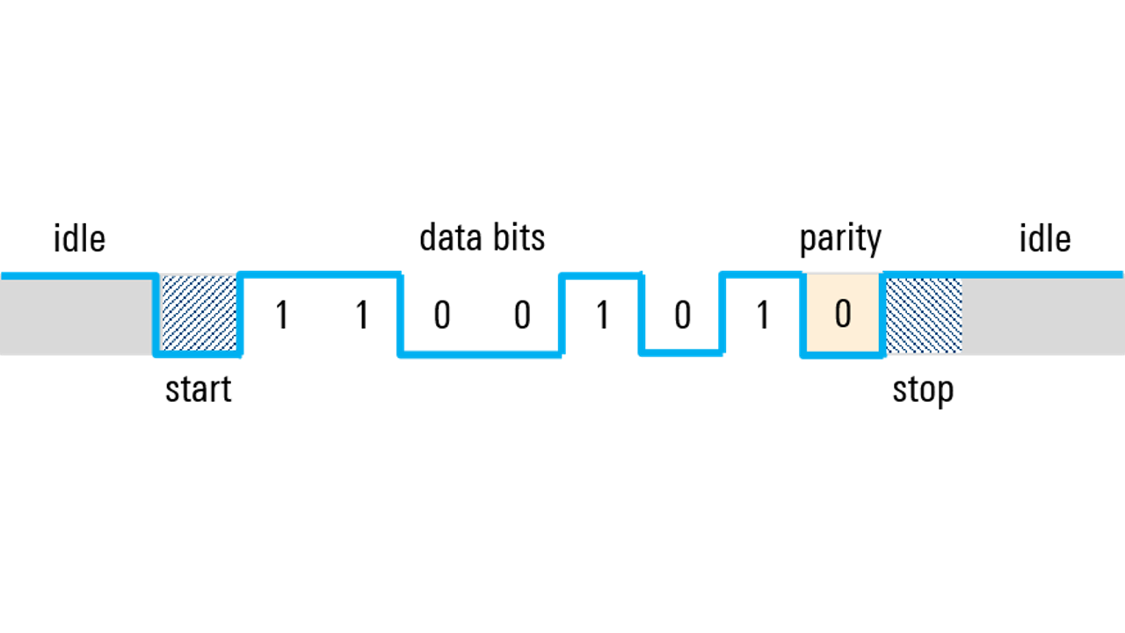

b) I2C Basics: I2C is a synchronous, multi-master, and multi-slave serial communication protocol used to connect various electronic components within a circuit. It typically consists of two wires:

* Serial Data (SDA): This is the bidirectional data line where information is transmitted between devices.
* Serial Clock (SCL): This is the clock signal that synchronizes data transmission between devices.

Now, let's go through the frame format of an I2C communication:

I2C Frame Format:

* Start Condition (S): Communication begins with a Start condition. It is a transition from a high to a low voltage level on the SDA line while the SCL line is high. The Start condition alerts all devices on the bus that a communication sequence is starting.
* Slave Address (7 or 10 bits):
  + 7-bit Address: In most cases, a 7-bit address is used to identify the target slave device. The most significant bit (MSB) of this byte is the Read/Write (R/W) bit, where '1' indicates a read operation and '0' indicates a write operation. The remaining 7 bits represent the slave device's address.
  + 10-bit Address: In some cases, a 10-bit address can be used for devices with extended address ranges. This is less common and not supported by all I2C devices.
* R/W Bit: Following the slave address, there's a Read/Write (R/W) bit. This bit specifies whether the operation is a read ('1') or write ('0') operation.
* Acknowledgment Bit (ACK): After receiving the slave address and R/W bit, the receiver (usually the slave device) sends an acknowledgment bit. If the receiver is ready to continue communication, it pulls the SDA line low during the ACK bit time. If not, it leaves the SDA line high (NACK) to signal the end of communication.
* Data Bytes: Depending on whether it's a read or write operation, one or more data bytes may follow. Each data byte is 8 bits long and is transferred with the most significant bit (MSB) first.
* Acknowledgment Bits for Data: After receiving each data byte, the receiver (slave or master) sends an acknowledgment bit. If the data byte was received correctly, the receiver pulls the SDA line low during the ACK bit time, indicating that it's ready for the next byte.
* Stop Condition (P): The communication concludes with a Stop condition. It is a transition from low to high on the SDA line while the SCL line is high. The Stop condition releases the bus for other devices to use and signals the end of the data transfer.

Example Sequence: Let's illustrate this with a simple example:

* Master wants to write data to a slave device with a 7-bit address of '1010000' (in binary).
* Master sends the Start condition (S).
* Master sends the slave address byte ('10100000') with the R/W bit set to '0' for write.
* Slave acknowledges (ACK).
* Master sends data bytes.
* After each data byte, the slave acknowledges.
* Master sends the Stop condition (P) to conclude the communication.

Remember that I2C communication can occur at various clock speeds (standard, fast, high-speed mode) depending on the devices and configuration. Also, addressing and data transmission can involve repeated Start conditions for read operations or for addressing multiple devices sequentially on the bus.

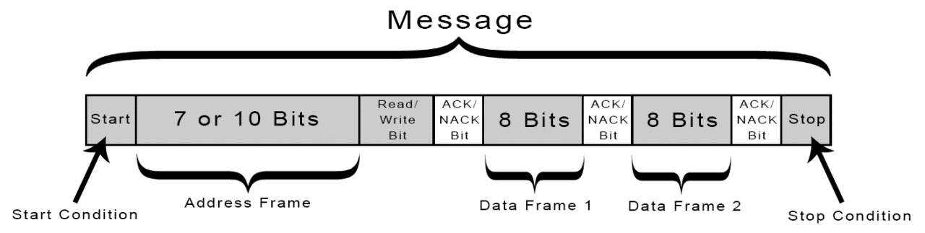

c) SPI (Serial Peripheral Interface) is a widely used synchronous serial communication protocol for connecting microcontrollers, sensors, and other peripheral devices to a central microcontroller or processor. It typically involves four lines:

* MOSI (Master Out Slave In): The Master sends data to the Slave on this line.
* MISO (Master In Slave Out): The Slave sends data to the Master on this line.
* SCLK (Serial Clock): This is the clock signal provided by the Master to synchronize data transmission.
* SS/CS (Slave Select/Chip Select): This line is used to select the target Slave device when multiple devices are connected to the same bus.

Here is the frame format of SPI communication:

SPI Frame Format:

* Clock Polarity (CPOL) and Clock Phase (CPHA): SPI can operate in different modes, and these two parameters determine the clock signal's behavior. CPOL and CPHA configure the clock polarity and phase, and they define when data is sampled and when it is transmitted.
  + CPOL (Clock Polarity):
    - 0: Clock idles at a low level (low when idle).
    - 1: Clock idles at a high level (high when idle).
  + CPHA (Clock Phase):
    - 0: Data is sampled on the leading (rising) edge of the clock signal.
    - 1: Data is sampled on the trailing (falling) edge of the clock signal.
* Bit Order (MSB/LSB First): SPI can transmit data in either Most Significant Bit (MSB) first or Least Significant Bit (LSB) first order.
* Data Size (Bits per Transfer): SPI can transfer a configurable number of bits in each frame, commonly 8 bits.
* Frame Transmission: SPI communication consists of a series of frames, each typically starting with the Slave Select (SS) line being asserted to select a specific Slave device.
  + Master sends data: The Master places data on the MOSI line.
  + Slave sends data: Simultaneously, the Slave places data on the MISO line.
  + Clock synchronization: Data is transferred bit by bit, synchronized to the SCLK signal, following the configured CPOL and CPHA settings.
  + Data sampling: At each clock edge, data is sampled by both the Master and the Slave.
* Slave Deselection: After transferring the desired number of bits, the Slave Select (SS) line is deasserted, indicating the end of communication with that particular Slave device.

Data is transmitted bit by bit, with each bit being synchronized to the rising or falling edge of the SCLK signal, depending on the CPOL and CPHA settings. The SS/CS line is used to select a specific Slave device for communication and is typically active low, meaning it's asserted (pulled low) to enable communication with a particular device.

The frame format can vary depending on the specific SPI mode, data size, and other configuration parameters set by the devices involved in the communication.

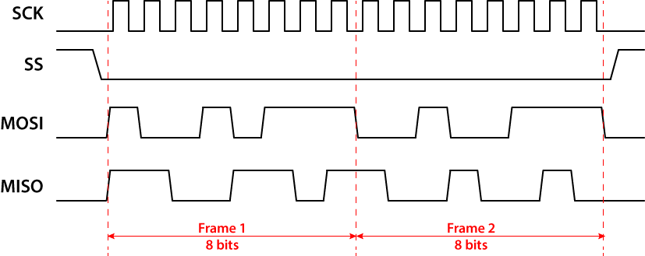

**4) What is the SPI communication protocol, and how is it used in embedded systems? What are the advantages and disadvantages of using SPI over other protocols?**

SPI, which stands for Serial Peripheral Interface, is a widely used synchronous communication protocol in embedded systems and microcontroller applications. It is primarily used for communication between microcontrollers or microprocessors and peripheral devices such as sensors, display drivers, memory chips, and more. SPI is popular due to its simplicity, reliability, and versatility in connecting multiple devices.

For working of SPI in embedded systems, refer the previous question.

SPI operates in a master-slave configuration, where the master device initiates communication by selecting a slave device using the SS/CS line. Data is then exchanged between the master and the selected slave(s) over the MOSI and MISO lines, synchronized by the SCLK signal.

Advantages of SPI:

* Simplicity: SPI is straightforward to implement and understand, making it an excellent choice for many embedded systems.
* High Speed: SPI operates at high data rates, which makes it suitable for applications that require rapid data transfer.
* InFull-Duplex Communication: SPI allows simultaneous data transmission and reception, which can improve efficiency in certain applications.
* Support for Multiple Devices: Multiple slave devices can be connected to a single master, and each can be selected individually using the SS/CS lines.
* Hardware-Based Communication: SPI communication is often hardware-based, meaning it is handled by dedicated hardware peripherals in microcontrollers, resulting in efficient and predictable timing.

Disadvantages of SPI:

* Limited Range: SPI is typically used for short-distance communication within a single circuit board. It is not suitable for long-distance communication.
* No Standardized Protocol: Unlike some other communication protocols like I2C or UART, SPI lacks a standardized protocol for higher-level functions such as addressing and data formatting. This can make it less plug-and-play friendly.
* Wiring Complexity: SPI requires multiple wires (at least four), which can lead to more complex wiring and routing in embedded systems.
* Not Suitable for Complex Networks: SPI is primarily a point-to-point or point-to-multipoint protocol and may not be suitable for complex network topologies.

**5)What are port pins and GPIOs in an Arduino board? How are they used in embedded systems design?**

In an Arduino board, port pins and GPIOs (General-Purpose Input/Output pins) are crucial components that play a significant role in embedded systems design. They are used for interfacing the microcontroller with external devices and sensors, making them a key part of the Arduino's flexibility and versatility.

1. Port Pins: Port pins are physical pins on the microcontroller chip that can be configured for various functions, including digital input and output, analog input, PWM (Pulse-Width Modulation) output, and more. These pins are often grouped into ports, and each port typically consists of multiple pins that share common functionality. Port pins are named according to their port and pin number (e.g., D2, A0).

In Arduino boards, port pins are often referred to as digital pins (e.g., D2, D7) or analog pins (e.g., A0, A5) depending on their primary function. Some digital pins can also support PWM output, allowing you to control the duty cycle of the output signal.

2. GPIOs (General-Purpose Input/Output pins): GPIOs are a subset of port pins, specifically designed for general-purpose input and output operations. They are the most versatile pins on the microcontroller, allowing you to read digital signals (HIGH or LOW) as inputs or set digital output values (HIGH or LOW). GPIOs are used for tasks such as interfacing with sensors, driving LEDs, controlling relays, and much more.

How Port Pins and GPIOs are Used in Embedded Systems Design: Port pins and GPIOs are fundamental to the design and functionality of embedded systems, including those built using Arduino boards. Here's how they are typically used:

* Sensor Interfacing: Port pins and GPIOs are commonly used to interface with various sensors, such as temperature sensors, light sensors, motion sensors, and more. The microcontroller reads analog or digital sensor data through these pins.
* Digital Output: GPIOs can be used to drive digital output devices, such as LEDs, displays, buzzers, and relays. By setting the pin to HIGH or LOW, you can control these external components.
* Digital Input: GPIOs are also used to read digital input signals from switches, buttons, or other digital sensors. The microcontroller can detect changes in the input state (e.g., button press) using these pins.
* Analog Input: Some port pins can be configured for analog input, allowing the microcontroller to measure analog voltages from sensors or potentiometers. This is often used for tasks like reading analog sensor values.
* PWM Output: Certain digital pins, which support PWM, are used for generating analog-like signals with varying duty cycles. This is useful for applications like motor control, dimming LEDs, and generating audio tones.
* Communication Interfaces: GPIOs are used for interfacing with communication modules such as SPI, I2C, UART, and more. These pins allow the microcontroller to communicate with other devices or microcontrollers.

**6) How does the I2C communication protocol work in embedded systems, and what are its key features?**

I2C (Inter-Integrated Circuit) is a widely used communication protocol in embedded systems for connecting microcontrollers to various peripheral devices, including sensors, EEPROMs, display modules, and more. It is a synchronous, multi-master, and multi-slave serial communication protocol known for its simplicity and versatility. Here's how I2C works and its key features:

How I2C Communication Protocol Works:

I2C communication involves two types of devices: masters and slaves. Masters initiate and control communication, while slaves respond to the masters' requests.

Refer to previous question for working

Key Features of I2C:

* Simplicity: I2C is relatively easy to implement and understand, making it a popular choice for communication in embedded systems.
* Multi-Master: I2C supports multiple master devices on the same bus, allowing for more complex communication scenarios and system configurations.
* Multi-Slave: Multiple slave devices can share the same bus, and each is addressed individually by its unique address.
* Bidirectional: I2C uses a bidirectional data line (SDA), enabling both data transmission and reception on the same wire.
* Synchronous: Communication is synchronized by the clock signal (SCL), ensuring data integrity and reliable transfer.
* Addressing: Devices are addressed with 7-bit addresses, providing support for up to 128 unique devices on the bus.
* Acknowledge Mechanism: The acknowledgment mechanism ensures that both master and slave devices confirm successful data transfer, reducing the chance of data corruption.
* Slow Data Rates: I2C is typically used for low to moderate data rates, making it suitable for applications that don't require high-speed communication.
* **7)With neat circuit diagram, explain the working of Successive Approximation ADC Type**
* A Successive Approximation Register (SAR) is added to the circuit Instead of counting up in binary sequence, this register counts by trying all values of bits starting with the MSB and finishing at the LSB. The register monitors the comparators output to see if the binary count is greater or less than the analog signal input and adjusts the bits accordingly
* **Successive Approximation ADC Circuit**
* 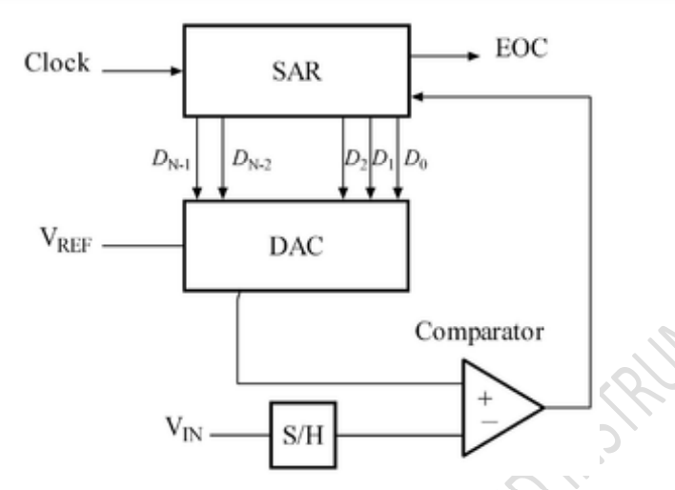
* Elements: DAC = Digital to Analog Converter
* EOC = End of Conversion
* SAR = Successive Approximation Register
* S/H = Sample and Hold Circuit
* Vin = Input Voltage
* Comparator
* Vref = Reference Voltage
* Algorithm
* Uses an n-bit DAC and original analog results
* Performs a binary comparison of VDAC and Vin
* MSB is initialized at 1 for DAC
* If Vin < VDAC (VREF / 2^n=1) then MSB is reset to 0
* If Vin > VDAC (VREF / 2^n) Successive Bits set to 1 otherwise 0
* Algorithm is repeated up to LSB
* At end DAC in = ADC out
* N-bit conversion requires N comparison cycles

**8)Explain the principle of DC motor speed control using PWM technique.**

DC motor speed control using PWM (Pulse Width Modulation) is a common technique in robotics and automation. The principle involves varying the average voltage supplied to the DC motor to control its speed. Here's how it works:

* Generating PWM Signal: The Arduino (or any microcontroller) generates a PWM signal with a specific duty cycle. The duty cycle represents the percentage of time the signal is high (ON) compared to the total time period of the signal. A higher duty cycle means a higher average voltage, which results in a faster motor speed.
* Driving the Motor: The PWM signal is applied to the motor through a motor driver circuit. The motor driver controls the voltage and current supplied to the motor based
* on the PWM input.
* Motor Response: The motor responds to the PWM signal by rotating at a speed proportional to the average voltage. When the duty cycle is high (e.g., 75%), the motor receives a higher average voltage and spins faster. When the duty cycle is low (e.g., 25%), the motor receives a lower average voltage and spins slower.
* Fine Speed Control: By adjusting the duty cycle of the PWM signal, you can precisely control the motor's speed. This allows for gradual acceleration, deceleration, and maintaining a constant speed.

PWM-based speed control is efficient and effective for DC motors because it doesn't dissipate excessive heat (as in resistive methods) and allows for precise control over the motor's speed, making it suitable for various applications like robotics, conveyor systems, and more.

**9)Why are motor drivers necessary for interfacing motors with an Arduino board, and how does an H-Bridge motor driver circuit work?**

Motor drivers are necessary for interfacing motors with an Arduino board (or any microcontroller) for several important reasons:

* Voltage and Current Compatibility: Arduino pins can typically provide only a limited amount of current (usually up to 20-40mA per pin) at 5V. Motors, especially DC motors, often require higher voltage and current to operate efficiently. Motor drivers act as a bridge between the low-power Arduino pins and the high-power requirements of the motors, ensuring that the motors receive the necessary voltage and current without damaging the Arduino.
* Direction Control: Most motors require the ability to change direction (forward and reverse). Motor drivers, such as H-Bridge circuits, provide the capability to reverse the motor's direction easily by changing the polarity of the voltage applied to the motor terminals.
* Speed Control: Motor drivers allow for precise speed control of motors through techniques like PWM (Pulse Width Modulation). PWM signals generated by the Arduino control the duty cycle of the voltage supplied to the motor, effectively controlling its speed.
* Protection: Motor drivers often include built-in protection features like overcurrent protection and thermal shutdown. These features help prevent damage to the motor and driver circuitry in case of overloads or overheating.

Now, let's delve into how an H-Bridge motor driver circuit works:

H-Bridge Motor Driver Circuit:

An H-Bridge is a popular type of motor driver circuit used to control the direction and speed of DC motors. It's called an "H-Bridge" because its schematic diagram resembles the letter 'H.' Here's a simplified explanation of how it works:

* Four Switches: An H-Bridge consists of four switching elements (usually transistors or MOSFETs) that can be turned on and off independently. These switches are arranged in an H-shaped configuration:
  + Two switches (S1 and S2) control the connection between the positive supply voltage (Vcc) and one terminal of the motor (M1).
  + The other two switches (S3 and S4) control the connection between the other motor terminal (M2) and ground (GND).
* Direction Control:
  + To make the motor rotate in one direction (e.g., clockwise), you would turn on switches S1 and S4 while keeping S2 and S3 off. This configuration applies a positive voltage to M1 and connects M2 to ground, causing the motor to spin in the desired direction.
  + To reverse the motor's direction (e.g., counterclockwise), you would turn on switches S2 and S3 while keeping S1 and S4 off. This configuration applies a positive voltage to M2 and connects M1 to ground, causing the motor to spin in the opposite direction.
* Speed Control (PWM):
  + To control the motor's speed, you can use PWM signals to control the duty cycle of the H-Bridge switches. By rapidly switching the H-Bridge switches on and off at a specific frequency (using PWM), you effectively vary the average voltage applied to the motor, which determines its speed. A higher duty cycle results in a faster motor speed, and a lower duty cycle results in a slower speed.
* Protection: Many H-Bridge motor driver ICs also include built-in protection mechanisms, such as overcurrent protection and thermal shutdown, to safeguard the motor and driver circuitry from damage due to excessive current or overheating.

H-Bridge motor drivers provide a flexible and efficient way to control the direction and speed of DC motors, making them suitable for a wide range of applications, including robotics, electric vehicles, and industrial automation.

**10) Explain the working principles of DC and stepper motors using a neat diagram?**

**DC Motor**:

A DC (Direct Current) motor converts electrical energy into mechanical motion. It operates on the principle of Lorentz force, where a current-carrying conductor placed in a magnetic field experiences a force.

* Basic Components:
  + Stator: The stationary part of the motor, typically with a permanent magnet that provides a magnetic field.
  + Rotor: The rotating part of the motor, usually consisting of coils of wire wound around a core.
* Working Principle:
  + When a voltage is applied across the terminals of the motor, current flows through the coils in the rotor.
  + Due to the interaction between the magnetic field from the stator and the magnetic field created by the current in the rotor, a torque is generated, causing the rotor to rotate.
  + The direction of rotation can be controlled by reversing the polarity of the applied voltage.
* Speed Control:
  + The speed of the DC motor can be controlled by varying the voltage applied to it. Higher voltage results in faster rotation, and lower voltage results in slower rotation.
  + PWM (Pulse Width Modulation) can be used for precise speed control.
* Applications:
  + DC motors are commonly used in various applications, including fans, power tools, conveyor belts, and vehicles (as starter motors).

Stepper Motor:

A stepper motor is an electromechanical device that converts digital pulses into precise angular movements. It moves in discrete steps, making it suitable for applications requiring precise positioning.

Here's a explanation:

* Basic Components:
  + Stator: The stationary part of the motor with multiple sets of coils (windings).
  + Rotor: The rotating part with teeth or poles that align with the stator windings.
* Working Principle:
  + Stepper motors operate by energizing the stator windings in a specific sequence.
  + When a particular winding is energized, it creates a magnetic field that attracts the rotor's teeth or poles.
  + By sequentially energizing the windings in the correct sequence, the rotor moves in discrete steps, typically 1.8 degrees per step for a common type (called a "1.8-degree stepper motor").
* Precise Control:
  + Stepper motors offer precise control of rotation. By controlling the sequence and timing of pulses sent to the windings, you can control the motor's position accurately.
* No Feedback Required:
  + Unlike some other motors, stepper motors do not require external feedback (e.g., encoders) to determine their position. The control system keeps track of the steps and knows the position at all times.
* Applications:
  + Stepper motors are widely used in applications requiring precise control of position or rotation, such as 3D printers, CNC machines, robotics, and camera systems.

In summary, DC motors rely on the interaction between a magnetic field and current-carrying conductors to produce rotation, with speed control achieved through voltage variation. Stepper motors, on the other hand, move in discrete steps based on sequential energization of windings, providing precise angular control without the need for feedback mechanisms.

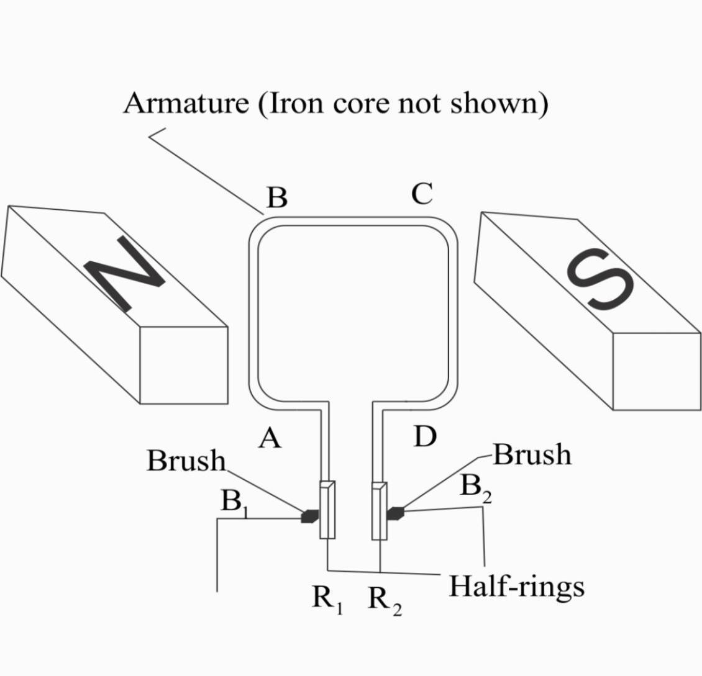DC Motor

